Part A frontsheet to Interests form
- Confidential registration with Monitoring Officer of usual residential address (if in the area of the Parish/Town Council)
Sections 29 and 32A of the Localism Act 2011
If your usual residential address is:
- not within the area of the Parish/Town Council, then it is not required to be registered at all with the Monitoring Officer as a disclosable pecuniary interest. Please tick the box below if this applies to you and then go straight to the Part B interests form:
My usual residential address is not within the area of the Parish/Town Council. 
- within the area of the Parish/Town Council, then please note and complete the following provisions of this Part A frontsheet carefully and then complete Part B.

Please note that unless you specifically opt-in to publishing your usual residential address (in the area of the Parish/Town Council) in the public Register of Members' Interests and on the Parish/Town Council's/North Yorkshire Council's websites, it will be held confidentially by the Clerk and Monitoring Officer and not published, under section 32A of the Localism Act 2011.
This sheet will not be published. It will be removed from your interests form before
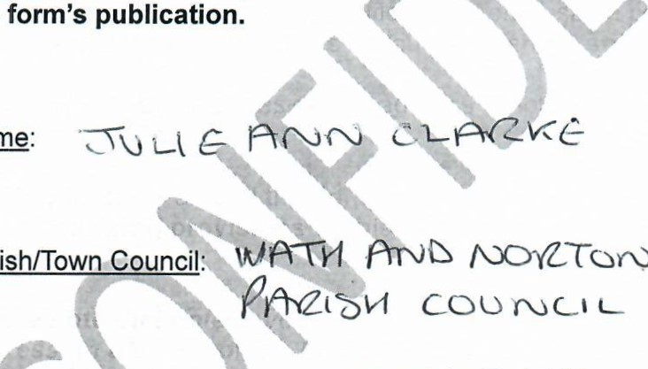
Name:
the
/\JOYZXOFO
Parish/Town

COAYGCCS
Usual residential address (in the area of the Parish/Town Council):
completed ifyou wish to opt-in to publication of your usual residential address which is in the area of the Parish/Town Council]
If you wish to opt-in to publishing your usual residential address, please tick the box below:
I wish my usual residential address to be published in the Register of Members' Interests and on the Parish/Town Council's/North Yorkshire Council's websites and I will include it in my interests form.
If you are opting-in to publication, please ensure you also inform the Clerk, as well as the Monitoring Officer.

REGISTER OF MEMBERS' INTERESTS
Section 29 Localism Act 2011 and associated legislation
PLEASE NOTE: this form is based on the LGA model code of conduct's registration of interests' requirements. Please refer to your parish/town council's individual code's requirements in completing this form.
Failure to comply with the requirements around registration of interests may constitute a criminal offence. If you have any queries about your interests, please contact the Clerk as soon as possible.
(Name)
a Member of PARISH/TOWN COUNCIL

Coo) ye^{t}-us
give notice that I have the following interests:

A. Disclosable pecuniary interests
I have the following disclosable pecuniary interests as described in the Relevant Authorities (Disclosable Pecuniary Interests) Regulations 2012 of which I am aware and which are my interests and those of my spouse/civil partner/partner with whom I am living as spouse or civil partner ("relevant persons").
1. Employment, office, trade, profession or vocation
You should register details of any employment, office, trade, profession or vocation carried on for profit or gain.
Councillor's Interest(s) | Councillor's spouse/partner's interest(s)
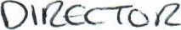  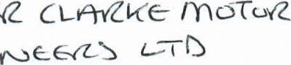  (ZOCG'Z 60 Cl  oroe ülOiNCiS m a-m G"Zßy  HCI | 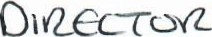  (206 cc Cl-PTYLVCe  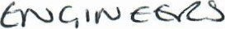

-1-
- Sponsorship
You should declare any payment or provision of any other financial benefit (other than from the Parish/Town Council) made or provided within the last 12 months in respect of any expenses incurred by you in carrying out duties as a member, or towards your election expenses.
  - This includes any payment or financial benefit from a trade union within the meaning of the Trade Union and Labour Relations (Consolidation) Act 1992.
Name of person or body making payment/other financial benefit
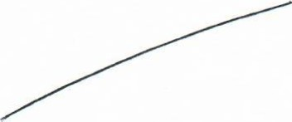
- Contracts
You should describe all contracts of which you are aware which are made between you/the relevant person (or a body in which you/the relevant person has a beneficial interest) and the Parish/Town Council:
(a) under which goods or services are to be provided or works are to be executed; and (b) which has not been fully discharged.
  - "body in which the relevant person has a beneficial interest" means a firm in which you/the relevant person is a partner or a body corporate of which you/the relevant person is a director, or in the securities of which you/the relevant person has a beneficial interest.
  - "director" includes a member of the committee of management of an industrial and provident society.
"securities" means shares, debentures, debenture stock, loan stock, bonds, units of a collective investment scheme within the meaning of the Financial Services and Markets Act 2000 and other securities of any description, other than money deposited with a building society.
Councillor's Interest(s) | Councillor's spouse/partner's interest(s)
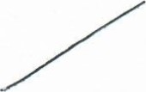 | 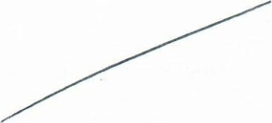

4A. Usual residential address (in the area of the parish/town council)
If your usual residential address is not within the area of the Parish/Town Council, it does not need to be registered at all as a disclosable pecuniary interest and therefore please delete the pre-populated wording in the box below and insert "N/A" instead.
If your usual residential address within the area of the Parish/Town Council, then as a matter of law, under section 32A Localism Act 2011, your usual residential address must not be published in the Register of Members' Interests unless you specifically request, in writing, to the Monitoring Officer, that it be so published. The existence of an interest should be noted, but not the detail itself and standard wording to this effect has been pre-populated in the box below.
(iii) If you are opting-in to publishing your usual residential address (in the area of the Parish/Town Council), please include it in the box below and delete the transparency wording pre-populated.
I have an interest under section 4A which has been disclosed confidentially to the Monitoring Officer but which is automatically withheld from publication under section 32A of the Localism Act 2011.
4B. Other Land interests (not your usual residential address)
Subject to section 4A above:
You should register any beneficial interest in land which is within the area of the Parish/Town Council.
"land" excludes an easement, servitude, interest or right in or over land which does not carry with it a right for you/the relevant person (alone or jointly with another) to occupy the land or to receive income.
Councillor's Interest(s) | Councillor's spouse/partner's interest(s)
 | 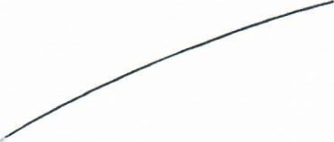

- 3-
or-F.ICIAI
- Licences
You should register any licence (alone or jointly with others) to occupy land in the area of the Parish/Town Council for a month or longer.
  - "land" excludes an easement, servitude, interest or right in or over land which does not carry with it a right for the relevant person (alone or jointly with another) to occupy the land or to receive income.
Councillor's Interest(s) | Councillor's spouse/partner's interest(s)
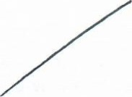 | 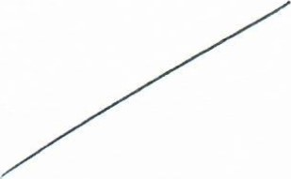
- Corporate Tenancies
(i) You should register any tenancy where (to your knowledge) —
    - the landlord is the Parish/Town Council; and
    - the tenant is a body in which you/the relevant person has a beneficial interest.
"body in which the relevant person has a beneficial interest" means a firm in which you/the relevant person is a partner or a body corporate of which you/the relevant person is a director, or in the securities of which you/the relevant person has a beneficial interest.
  - "director" includes a member of the committee of management of an industrial and provident society.
  - "securities" means shares, debentures, debenture stock, loan stock, bonds, units of a collective investment scheme within the meaning of the Financial Services and Markets Act 2000 and other securities of any description, other than money deposited with a building society.
Councillor's Interest(s) | Councillor's spouse/partner's interest(s)
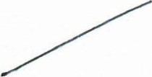 | 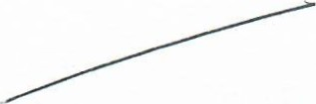
- Securities
You should register any beneficial interest in securities of a body where—
    - that body (to your knowledge) has a place of business or land in the area of the Parish/Town
Council; and
    - either—
the total nominal value of the securities exceeds E25,OOO or one hundredth of the total issued share capital of that body; or
ll. if the share capital of that body is of more than one class, the total nominal value of the shares of any one class in which you/the relevant person has a beneficial interest exceeds one hundredth of the total issued share capital of that class.
  - "securities" means shares, debentures, debenture stock, loan stock, bonds, units of a collective investment scheme within the meaning of the Financial Services and Markets Act 2000 and other securities of any description, other than money deposited with a building society.
Councillor's Interest(s) | Councillor's spouse/partner's interest(s)
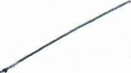 | 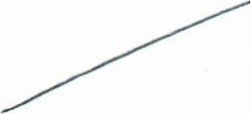

B. Other Reqistrable Interests (other than disclosable pecuniary interests)
I also have the following Other Registrable Interests (as required to be registered by the Parish/Town Council's Code of Conduct for Members):
NB - In this section, the Code only requires Councillor interests to be disclosed (not those of a spouse/partner/civil partner).
1. Unpaid directorships
You should register details of any unpaid directorships you hold.
Name of body | Details
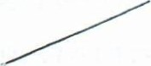 | 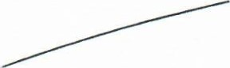

- 5 -
OFF-ICIAI
- Bodies to which you are nominated by the Parish/Town Council
You should register details of any body of which you are a member or are in a position of general control or management and to which you are nominated or appointed by your authority.
Name of body | Details
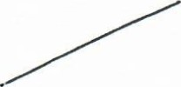 | 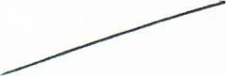
- Public bodies
You should register details of any body exercising functions of a public nature of which you are a member or in a position of general control or management.
Name of body | Details
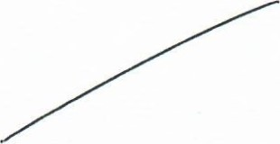 | 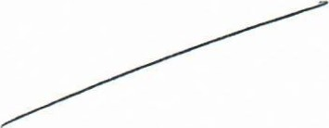
- Charitable bodies
You should register details of any body directed to charitable purposes of which you are a member or in a position of general control or management.
Name of body |  | Details
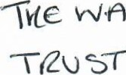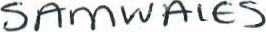  VAJRTH | 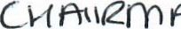  T(ZosT | 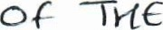
- Political parties/Trade Union/Professional Association membership
You should register details of any body one of whose principal purposes includes the influence of public opinion or policy (including any political party or trade union/professional association) of which you are a member or in a position of general control or management.
Name of body | Details
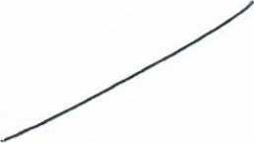 | 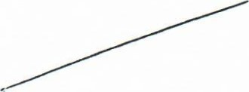
- Any other interests required to be registered under the Parish/Town Council Code
You should register in this section any other interests required to be registered by your authority's code of conduct for Members (not covered by the LGA model code).
Interest | Details
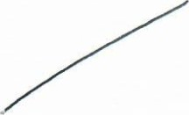 | 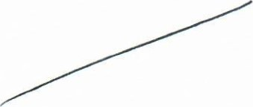

DECLARATION
I declare that the above information is complete and accurate to the best of my knowledge.
I understand that my usual residential address (if in the area of the Parish/Town Council) will not be published unless I explicitly request publication.
I recognise that it is a breach of the Authority's Code of Conduct and may be a criminal offence to:
- omit, without reasonable excuse, information that ought to be given in this notice;
- provide information that I know to be false or misleading;
- provide information where I am reckless as to whether the information is true and not misleading;
OFFICIAI

- fail to give further notice, within 28 days of becoming aware of any new disclosable pecuniary interest or change to the interests specified, in order to bring up to date the information given in this notice.
Signed 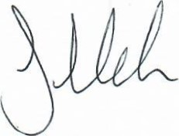 Date 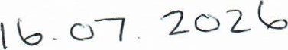
Please return to:
• the Clerk of the Parish/Town Council; and also the Monitoring Officer at North Yorkshire Council at MonitoringOfficer@northyorks.gov.uk

- 8-

